Project - High Level Design
on
Telecom Quiz / Tutor Bot
  - Course Name: Generative AI
Institution Name: Medicaps University – Datagami Skill Based Course

Student Name(s) & Enrolment Number(s):
Sr no | Student Name | Enrolment Number
1. | Isha Joshi | EN22CS301438
2. | Harsh Chouhan | EN22CS301387
3. | Gautam Choudhary | EN22CS301370
4. | Goutam Sharma | EN22CS301374
5. | Harshita Chouhan | EN22CS301406

Group Name: Group 03D4
Project Number: GAI-39
Industry Mentor Name:
University Mentor Name:
Academic Year:2026

Table of Contents
Sr No. | Contacts | Page No.
1. | Introduction | 3-4
 | 1.1 Scope of the document
 | 1.2 Intended Audience
 | 1.3 System Overview
2. | System Design | 4-10
 | 2.1 Application Design
 | 2.2 Process Flow
 | 2.3 Information Flow
 | 2.4 Components Design
 | 2.5 Key Design Considerations
 | 2.6 API Catalogue
3. | Data Design | 11-12
 | 3.1 Data Model
 | 3.2 Data Access Mechanism
 | 3.3 Data Retention Policies
 | 3.4 Data Migration
4. | Interfaces | 12
5. | State and Session Management | 13
6. | Caching | 13
7. | Non-Functional Requirements | 13-14
 | 7.1 Security Aspects
 | 7.2 Performance Aspects
8. | References | 14

High Level Design (HLD)
1. Introduction
The Telecom Quiz / Tutor Bot is an AI-powered educational system designed to assess and improve users’ knowledge in the Telecom domain. The system generates telecom-related quiz questions, evaluates user responses using a Local Large Language Model (Ollama – gemma3:1b), and provides contextual explanations for incorrect answers.
The system integrates FAISS (Vector Database) for semantic retrieval of telecom plan details and implements adaptive learning mechanisms for personalized assessment.

1.1 Scope of the Document
This document defines the High-Level Design (HLD) of the Telecom Quiz / Tutor Bot. It includes:
- System architecture overview
- Application and component design
- Process and information flow
- Data design
- API catalogue
- Non-functional requirements
- Security and performance aspects
The document explains how different modules interact to deliver an AI-driven quiz system.

1.2 Intended Audience
This document is intended for:
- Industry Mentor
- University Mentor
- Project Evaluators
- Developers

- System Architects

1.3 System Overview
The Telecom Tutor Bot is an interactive quiz system that:
- Allows users to select telecom topics
- Retrieves relevant telecom plan data using FAISS
- Generates quiz questions using Ollama (gemma3:1b)
- Evaluates answers using LLM reasoning
- Provides score and contextual explanation
- Tracks performance for adaptive learning
Architecture Type:
Local LLM + FAISS Vector Search + Modular Python Backend

2. System Design
The system follows a modular architecture with clearly separated responsibilities.
Major Modules:
- User Interface (CLI/Web)
- Query Engine (Core Logic)
- Knowledge Base (plans.py)
- Vector Store (FAISS)
- LLM Client (Ollama gemma3:1b)
- Session Management

2.1 Application Design
Project Folder Structure:
telecom_bot/
│
├── data/
│ └── plans.py
│
├── embeddings/
│ └── vector_store.py
│
├── llm/
│ └── gemma_client.py
│
├── bot/
│ └── query_engine.py
│
├── app.py
└── requirements.txt
Each module is independent and loosely coupled to improve maintainability and scalability.

2.2 Process Flow
Question Generation Flow
- User selects topic
- Query Engine fetches telecom plan data
- FAISS retrieves relevant semantic context
- LLM generates question
- Question displayed to user
Answer Evaluation Flow
- User submits answer
- Query Engine builds evaluation prompt
- LLM evaluates answer

- Score and explanation generated
- Performance updated

2.3 Information Flow
User
→ app.py
→ query_engine.py
→ plans.py (knowledge base)
→ vector_store.py (FAISS retrieval)
→ gemma_client.py (LLM evaluation)
→ Response returned to user
All communication is orchestrated through the Query Engine.

2.4 Components Design
plans.py
Stores telecom plan details and concept descriptions.
vector_store.py
- Generates embeddings
- Stores vectors in FAISS
- Performs similarity search
gemma_client.py
- Connects to Ollama
- Sends prompts
- Returns LLM responses
query_engine.py
- Controls question generation
- Manages evaluation logic
- Coordinates between modules

- Entry point
- Handles user interaction

2.5 Key Design Considerations
- Use of Local LLM to reduce API dependency
- Semantic search using FAISS
- Modular architecture
- Adaptive learning mechanism
- Efficient vector indexing
- Maintainability and scalability

2.6 API Catalogue
Internal APIs:
- generate_question(topic)
- evaluate_answer(answer, context)
- similarity_search(query_vector)
- get_plan_details(topic)
These APIs are invoked between backend modules.

UML Diagrams :-

Sequence Diagram
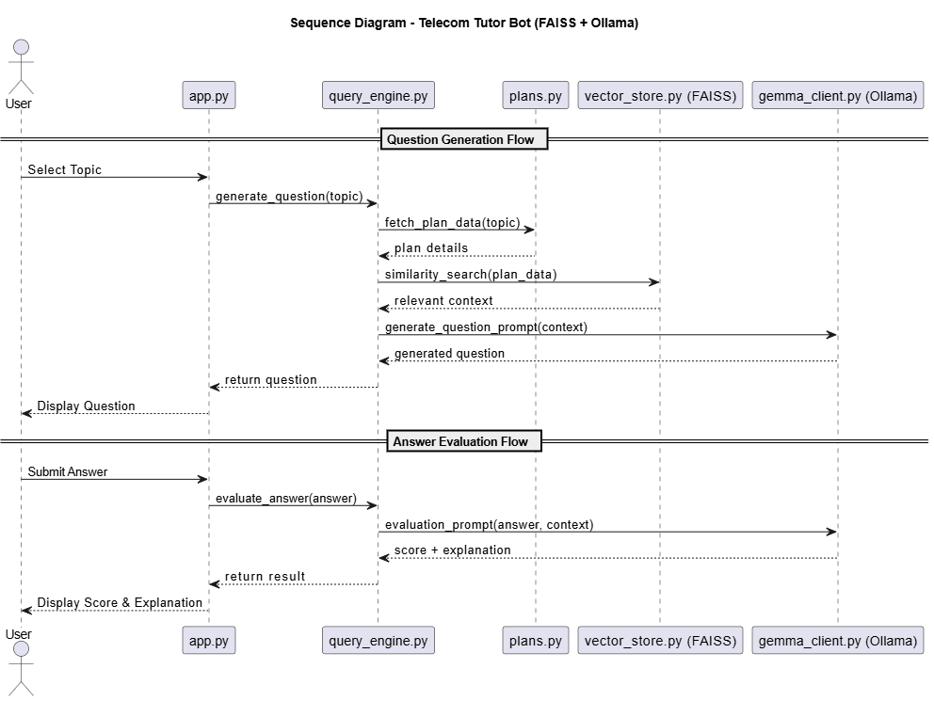

Activity Diagram
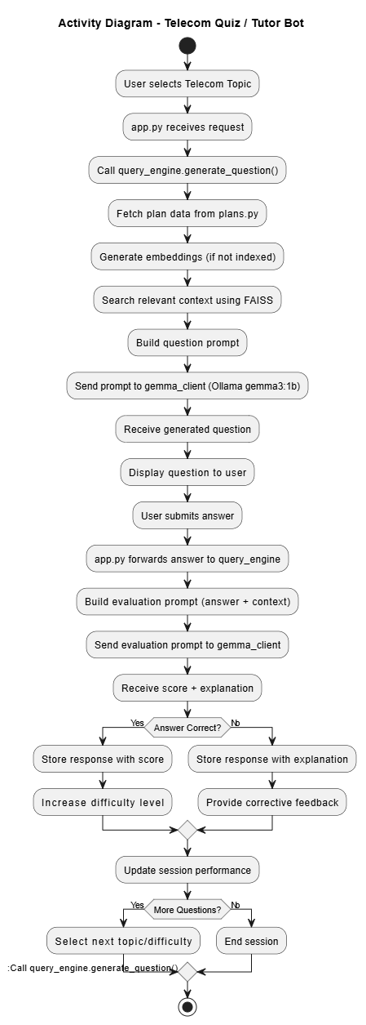

Entity Relationship Diagram

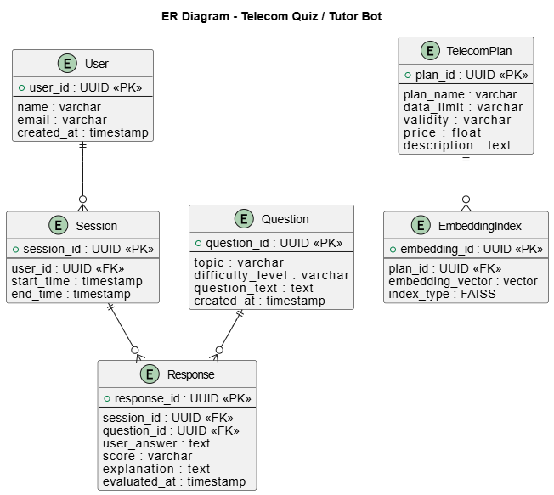

3. Data Design
The system manages both learning data and telecom knowledge data.

3.1 Data Model
User
- user_id
- name
Session
- session_id
- user_id
Question
- question_id
- topic
- difficulty
Response
- response_id
- session_id
- question_id
- user_answer
- score
- explanation
TelecomPlan
- plan_id
- plan_name
- data_limit
- validity

- price
- description

3.2 Data Access Mechanism
- Telecom plan data retrieved from plans.py
- Embeddings accessed via FAISS
- Evaluation results returned by Ollama LLM
- Session data stored in memory or local storage

3.3 Data Retention Policies
- Session data stored for active runtime
- Performance logs may be stored locally
- No external cloud storage used
- Data can be cleared manually

3.4 Data Migration
Currently:
- No external database migration required
- Future scope includes migration to relational databases such as PostgreSQL

4. Interfaces
User Interface:
- CLI-based interaction (current implementation)
- Extendable to web interface
LLM Interface:
- Ollama API-style local LLM calls
Vector Interface:

- FAISS similarity search

5. State and Session Management
- Session created per user interaction
- Performance tracked within session
- Difficulty adjusted based on previous responses
- Adaptive learning maintained per session

6. Caching
- FAISS index cached in memory
- Pre-generated embeddings stored locally
- Reduces repeated computation

7. Non-Functional Requirements
Reliability
- Local LLM ensures independence from external APIs
Maintainability
- Modular folder structure
Scalability
- Components can be extended independently
Usability
- Interactive conversational format

7.1 Security Aspects
- Local LLM ensures data privacy
- Input validation for user responses

- No external API exposure

7.2 Performance Aspects
- FAISS enables fast semantic search
- Local LLM reduces latency
- Lightweight Python architecture ensures efficient execution

8. References
- FAISS Documentation
- Ollama Documentation
- gemma3:1b Model Documentation
- Python Official Documentation

